Welcome to

2nd Grade

Here is a list of supplies that your child will need at the beginning of the new school year.

* $30 (Cash or checks made to SWE)
* 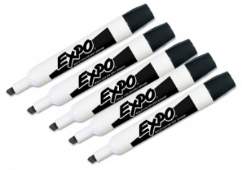Class fees will be used for class materials, supplies for projects, classroom incentives, and annual subscriptions.

**Shared Classroom Supplies**

* 5 black Expo dry-erase markers
* 1 box of Ticonderoga pencils – teachers love the pre-sharpened pencils
* 5 Elmer’s glue sticks
* 1 box of tissues

**Personal Items**

* Headphones – sturdy and plug-in (foldable if possible)
* 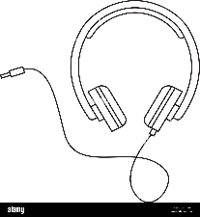Reuseable water bottle